

Aligned pictures of 4 directions

Photometric Stereo : This time I fixed the camera of ipad instead of mobile phone to shoot the chip because ipad only have 1 camera, and each time I turned the light from different directions to the chip, each time I turned 90°. The above image is the result of aligning the image rotation and cropping.

In those images, the text region is clearer than mobile phone because I shortened the distance between the camera and chip.

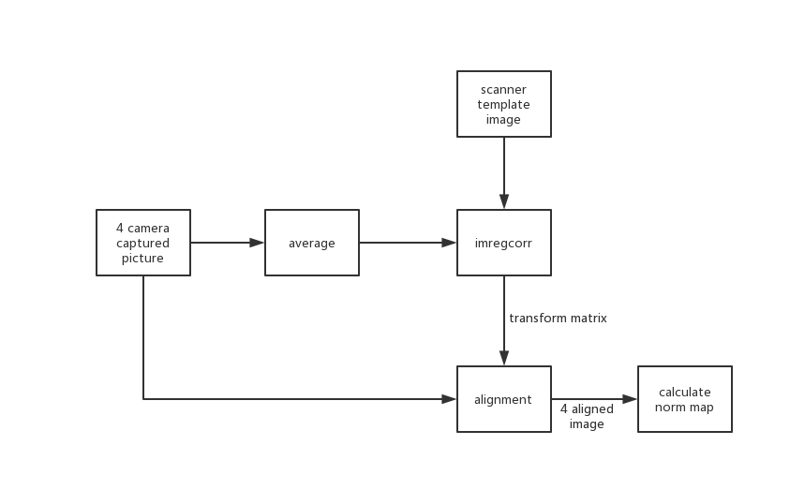

block diagrams

Using ipad’s camera, I still get the similar results of the correlation (in the excel) as mobile phone. In this case norm map Y has a better performance than norm map X. we can observe that the mismatched cases have a lower correlation.

There is an interesting result. When I calculate the correlation (in the excel) between the camera and scanner’s norm map, chip2 are high in X direction when they are matched and chip3 and chip4 are high in Y direction.

For those pairs of high and low correlation, I calculate the height map of both scanner and camera, then decompose the height map into 10 scale-space subbands and calculate correlation(in the excel) for the height map of each subband. We only have the confocal data of chip1 and chip4, I didn't use the uniform coefficient because the difference between the two chips in each case is large, and the difference between the x and y directions is also large.

Device model information :

Camera: iPad 2018

Scanner: Canon LIDE 110

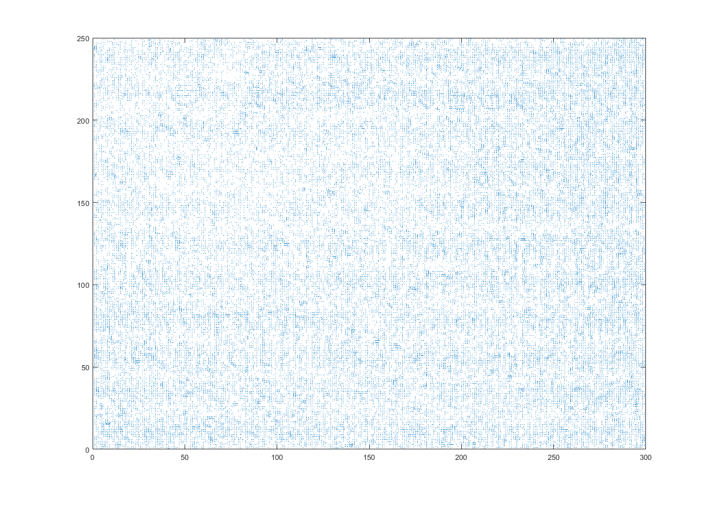

Norm map of chip2 from camera

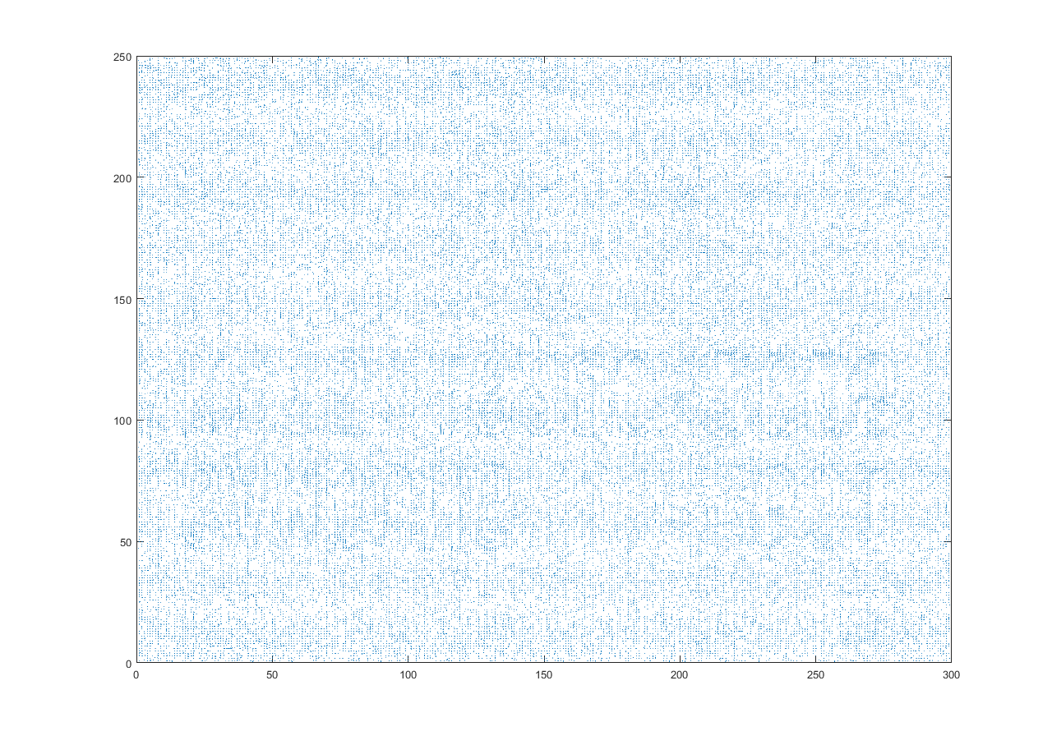

Norm map of chip2 from scanner

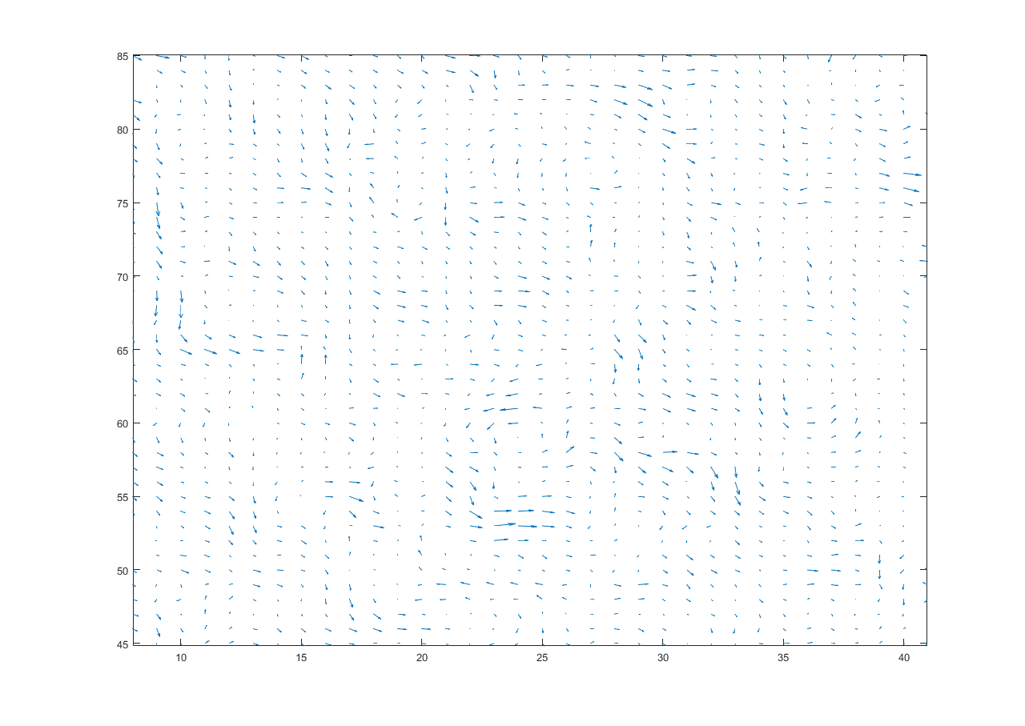

Upside down ‘S’ (camera)

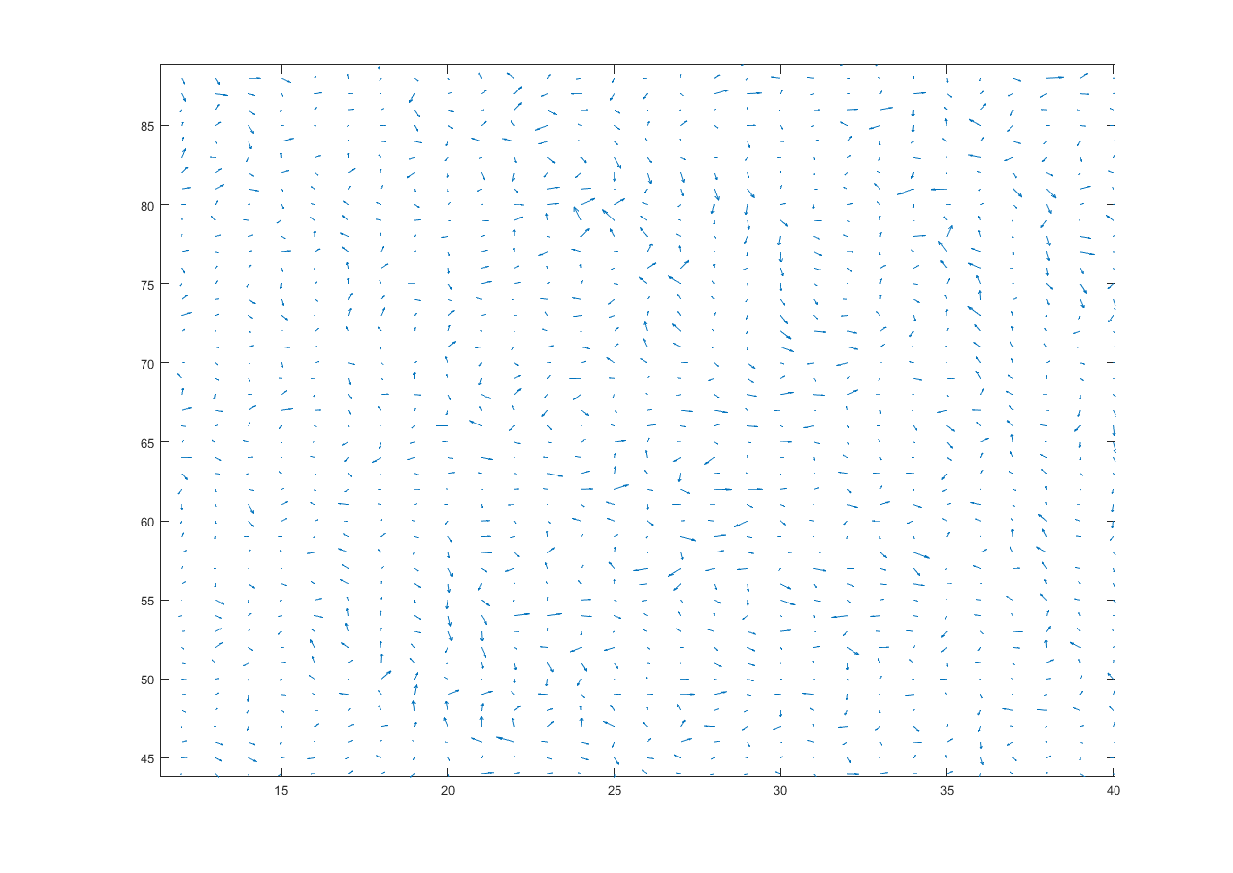

Upside down ‘S’ (scanner)

Comparing the enlarged norm map of the scanner and the camera, we can observe that, for the camera, all vectors in a small local area will have the similar direction. But for the scanner, we can’t find these area.

The reason of this phenomenon may be that the scanner can observe more details, so each vector is useful and precise, but the camera cannot capture the exact details, only the conspicuous features can be presented, so the same area can be observed because the details above are ignored.

Using the confocal data, the height map can be drawn.

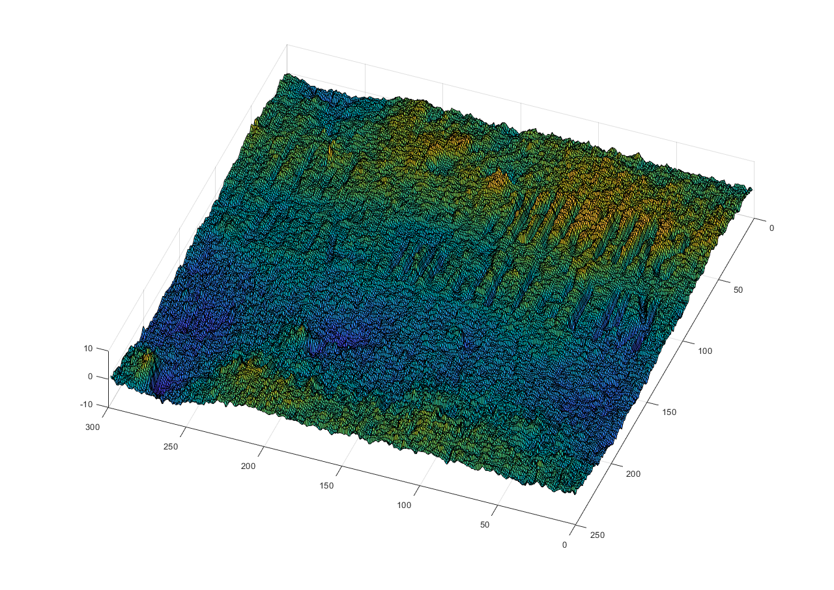

Height map of chip1 from scanner

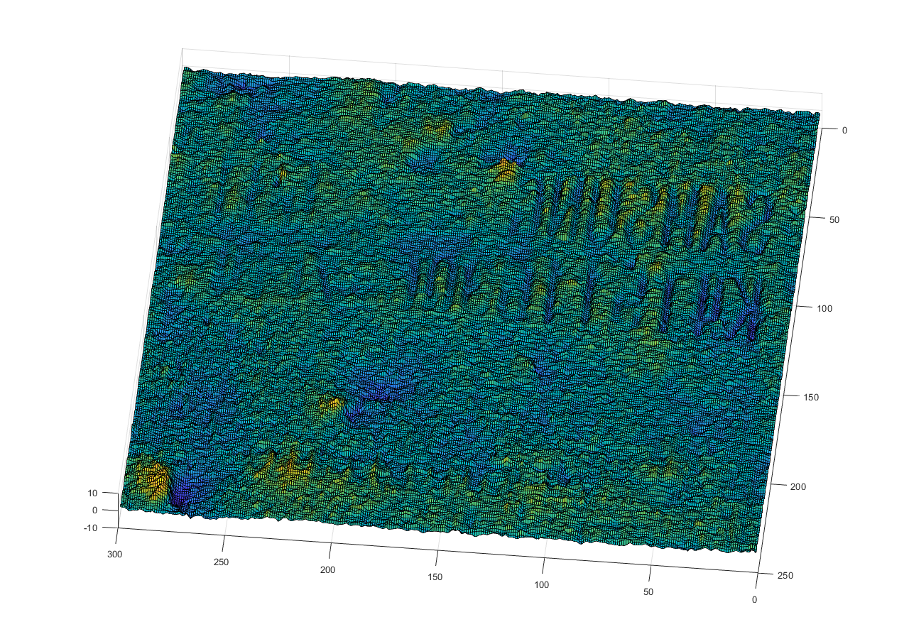

Removing trend

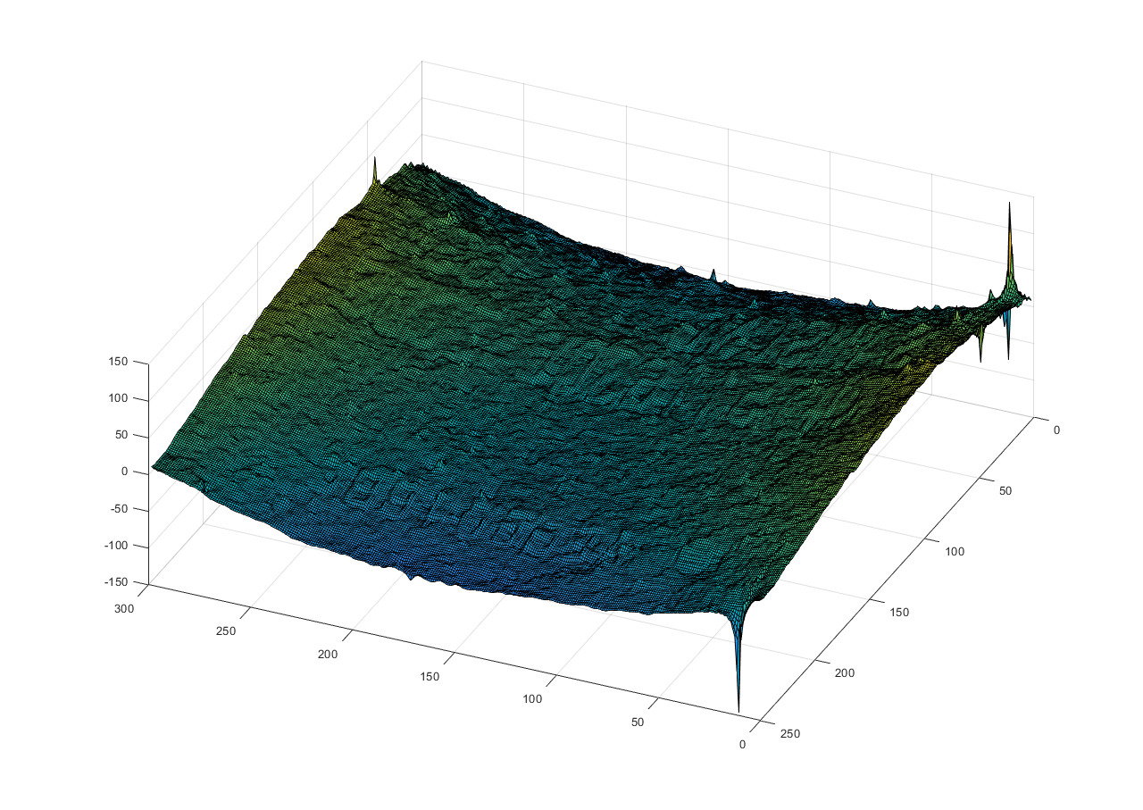

Height map of chip1 from camera

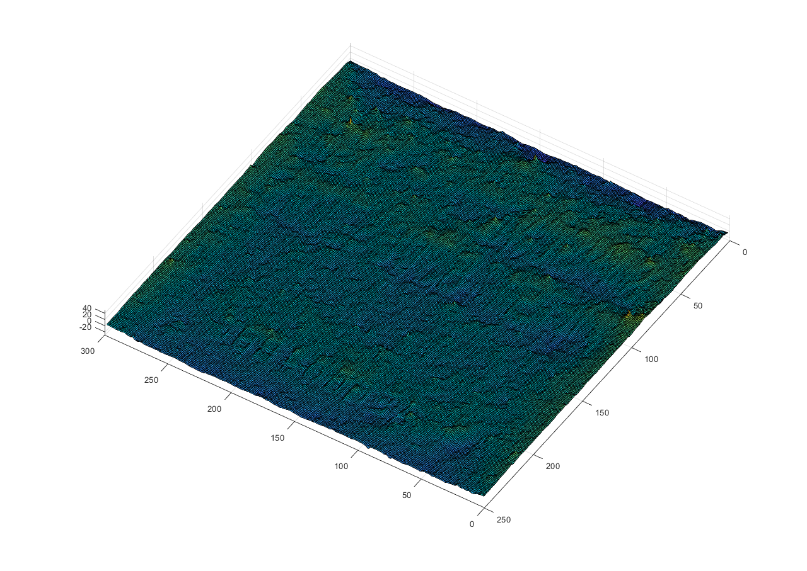

Removing trend

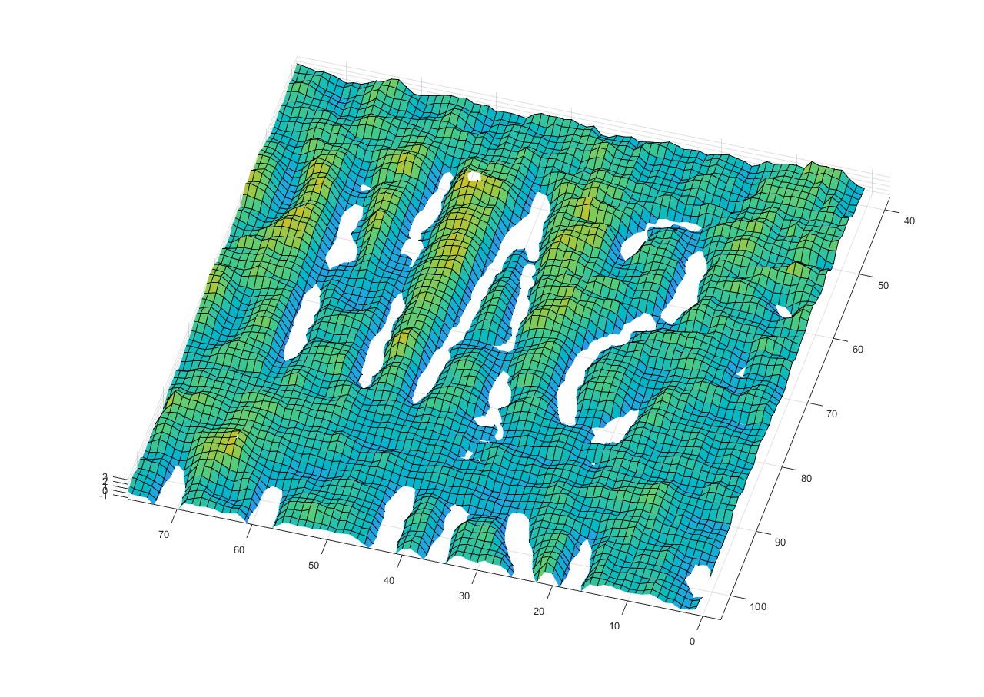

‘AS’ (scanner)

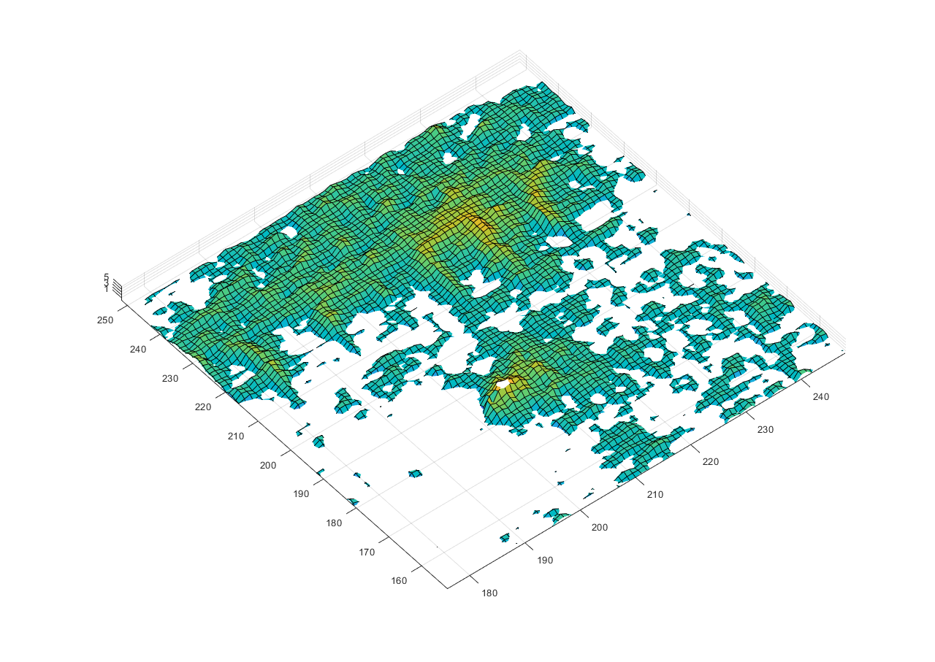

Text region below (scanner)

In scanner’s height map, the text region ‘SAMSUNG’ in the top area is concave, and the surrounding area is higher than the text. This area is same as the confocal height map. However, the text region below is higher than the surrounding area, which is in conflict with the confocal height map. Displaying image with scaled colors, we can see this phenomenon clearer.



Image with scaled colors (scanner)

The text region below is high. There must be something wrong when using norm map and confocal data to construct the height map.

As for camera’s case, text regions are all higher that the surrounding area.

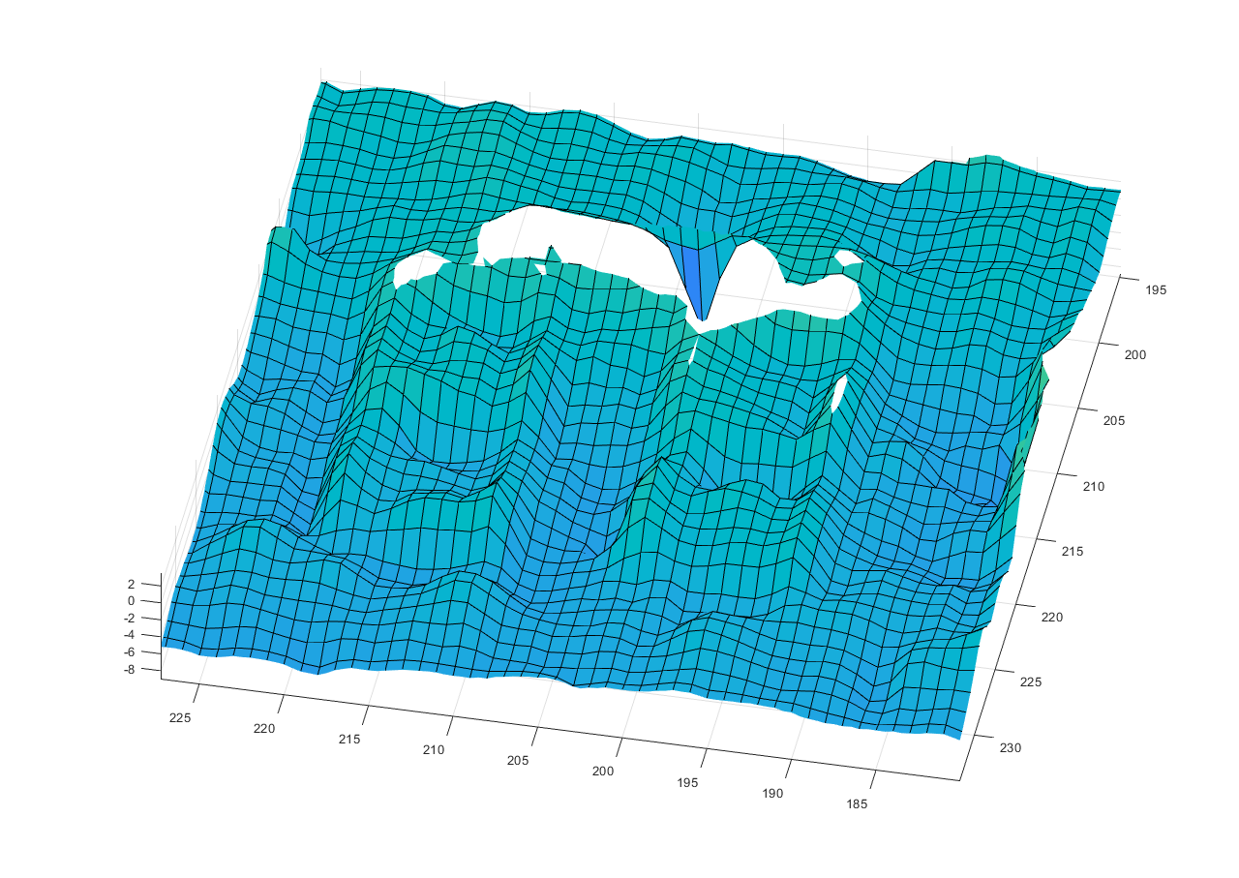

‘BB’ (camera)



Image with scaled colors (camera)









Blue line is the height map from scanner or camera. Red line is the trend blurred by Gaussian blur. .Gaussian sigma=25.

Randomly select five lines for drawing.

From the slice we can observe that the up and down fluctuations of the scanner are significantly more frequent than the camera. The norm map calculated by the camera is still inaccurate.